PHASE 7: Future Enhancements & Conclusion
1. Objectives
- To identify possible future improvements for the IT ticket classification system.
- To improve the system with additional automation features.
- To support better ticket management and tracking.
- To summarize the overall project outcome and benefits.
- To provide a foundation for future scalability and enhancement.
2. Activities Performed
Activity 1: Identify Future Enhancements
- Identify Assignment Automation as a future enhancement.
- Consider SLA Tracking for better ticket monitoring.
- Consider Predictive Intelligence for advanced ticket classification.
- Identify additional automation opportunities.
Activity 2: Final Project Review
- Review the complete ticket classification workflow.
- Review the automation and notification process.
- Review the testing and validation results.
- Summarize the project implementation and outcome.
Activity 3: Project Conclusion
- Document the final project results.
- Explain how the system reduces manual classification.
- Document the benefits of automated ticket classification.
- Record possible future improvements.
3. Expected / Produced Output
- Future enhancement plan.
- Documented assignment automation possibilities.
- SLA tracking enhancement plan.
- Predictive intelligence enhancement plan.
- Final project summary.
- Complete project conclusion.
- A scalable and maintainable ticket classification solution.
4. Data Flow Diagram – Flowchart
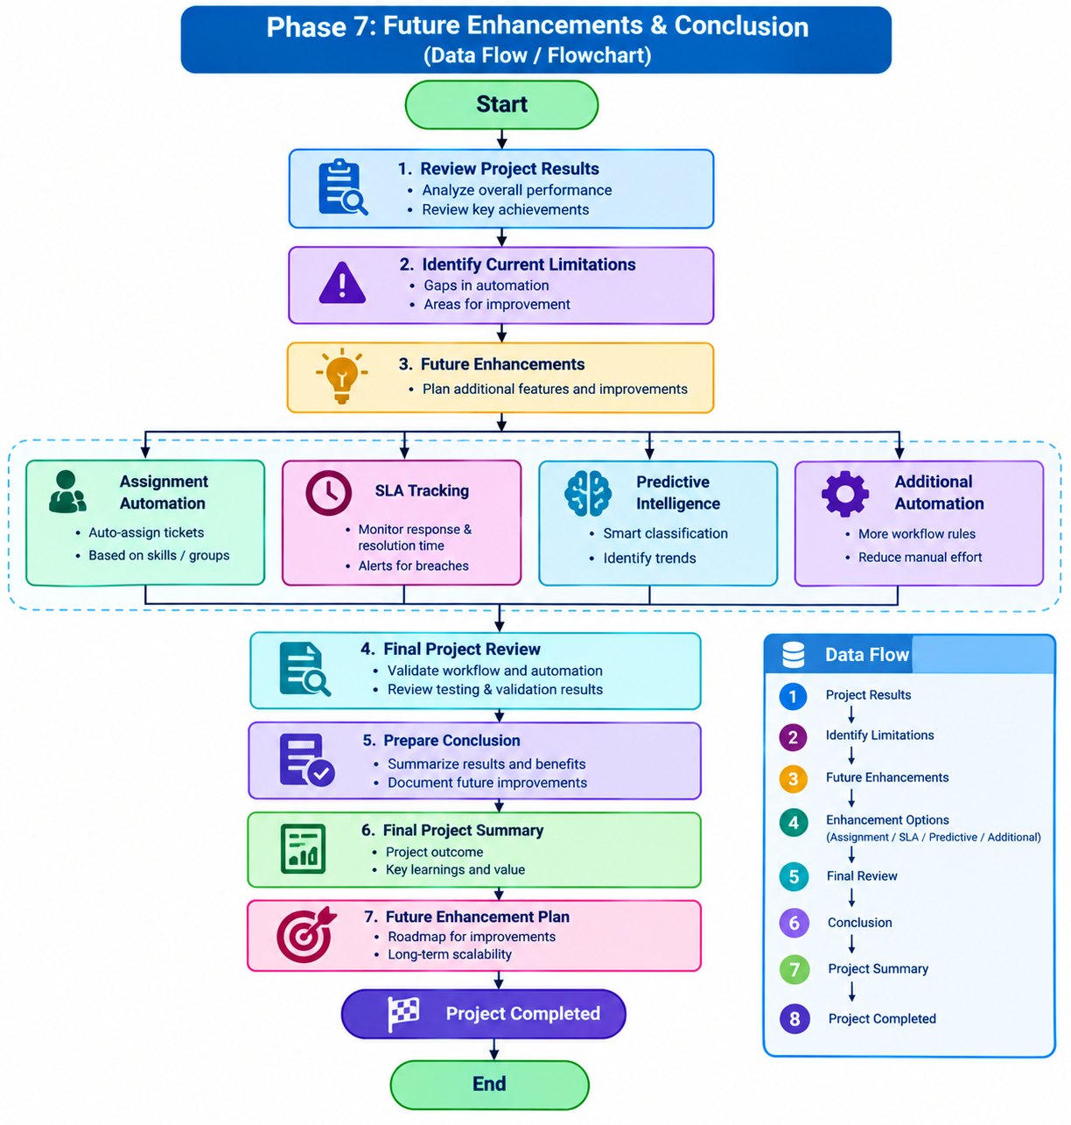

Data Flow:
Project Results → Limitations → Future Enhancements → Final Review → Conclusion → Project Summary → Project Completed.

